FIRE ALARM DETECTION

Submitted in partial fulfillment of the requirements

For the subject of

IOT (Mini Project) Lab

By

Mr. Pranav Salve

55

Mr. Devang Shinde

61

Mr. Sachin Tambe

68

Mr.Pritam Turalkar

71

Under the Supervision of

Prof K.S.Yadav



DEPARTMENT OF INFORMATION TECHNOLOGY

KONKAN GYANPEETH COLLEGE OF ENGINEERING KARJAT-410201

**Certificate**

This is to certify that the project entitled ‘Fire Alarm’ is

a bonafide work of Mr. Pranav M Salve (Roll No.55), Mr.Devang P Shinde(Roll No.55), Mr. Sachin S Tambe (Roll No.68) And Mr.Pritam R Turalkar(Roll No.71) submitted to the Department of Information Technology in partial fulfillment of the requirement for the subject of IOT (Mini Project)Lab.

|  |  |
| --- | --- |
| Supervisor/Guide | Head of Department |
| Professor | Professor |
| Department of Information Technology | Department of Information Technology |

**Project Report Approval**

This project report entitled ‘Fire Alarm’ by Mr. Pranav Salve(Roll No.55), Mr. Devang Shinde(Roll No.61), Mr.Sachin Tambe(Roll No.68) And Mr.Pritam Turalkar(Roll No71) is approved under the supervision of Project Guide Prof K.S.Yadav and Principle Dr. M. J. Lengare for the partial fulfillment of the requirement for the subject of IOT (Mini Project) Lab.

Examiners

1..........................................

2..........................................

Date.

Place.

**Declaration**

I declare that this written submission represents my ideas in my own words and where other ideas or words have been included, I have adequately cited and referenced the original sources. I also declare that I have adhered to all principles of academic honesty and integrity and have not misrepresented or fabricated or false any idea/data/fact/source in my submission. I understand that any violation of the above will be cause for disciplinary action by the Institute and can also evoke penal action from the sources which have thus not been properly cited or from whom proper permission has not been taken when needed.

(Mr. Pranab M Salve) Roll No

Signature

(Mr.Devang P Shinde) Roll No

Signature

(Mr.Sachin S Tambe) Roll No

Signature

(Mr.Pritam R Turalkar) Roll No

Signature

Date.

**Abstract**

Most of the fire detection are performed by sensor-based systems which have perceived the temperature and smoke by themselves and utilized in various type of industry after combining with the fuzzy theory. Generally this kind of methodology is useful for many spots of fire occurrences. However, it could not satisfy the requirement of accuracy and reliability on some environment. For example, large spaced factories, common area of electric power facility, communication facility are vulnerable to

**Acknowledgements**

We wish to express our profound and sincere gratitude to Prof. S.K.Yadav, Department Information Technology, KGCE, Karjat, who guided us into the intricacies of this project with matchless magnanimity.

We thank Prof. J. P. Patil, Head of the Dept. of Information Technology,

KGCE Karjat and Dr. M. J. Lengare, Principal, KGCE Karjat for extending their

support during the Course of this investigation.

We would be failing in our duty if we don’t acknowledge the co-operation Rendered during various stages of image interpretation by. We are highly grateful to who evinced keen interest and invaluable support in the progress and successful completion of our project work.

We are indebted to for their constant encouragement, co-operation and help. Words of Gratitude are not enough to describe the accommodation and fortitude which they have shown throughout my endeavor.

NAMES OF THE CANDIDATES

Pranav Salve

Devang Shinde

Sachin Tambe

Pritam Turalkar

**Contents**

|  |  |  |  |  |  |
| --- | --- | --- | --- | --- | --- |
| Certificate | | | |  | I |
| Project Report Approval | | | | | Ii |
| Declaration | | | |  | Iii |
| Abstract | | | |  | Iv |
| Acknowledgements | | | | | V |
| Contents | | | |  | Vi |
| List of Figures | | | | | Viii |
| 1 | INTRODUCTION | | | | 1 |
|  | 1.1 | | Introduction .. . . . . . . . . . . . . . . . . . . . . . . . . . . . . . . . . . . | | 1 |
|  | 1.2 | | Objectives .. . . . . . . . . . . . . . . . . . . . . . . . . . . . . . . . . . . . | | 1 |
|  | 1.3 | | Purpose, Scope, and Applicability .. . . . . . . . . . . . . . . . . . . . . . | | 1 |
|  |  | | 1.3.1 | Purpose .. . . . . . . . . . . . . . . . . . . . . . . . . . . . . . . . . | 1 |
|  |  | | 1.3.2 | Scope .. . . . . . . . . . . . . . . . . . . . . . . . . . . . . . . . . . | 2 |
|  |  | | 1.3.3 | Applicability .. . . . . . . . . . . . . . . . . . . . . . . . . . . . . . | 2 |
|  | 1.4 | | Achievements .. . . . . . . . . . . . . . . . . . . . . . . . . . . . . . . . . . | | 2 |
|  |  |
| 2 | LITRERATURE SURVEY | | | | 3 |

|  |  |  |  |  |
| --- | --- | --- | --- | --- |
| Contents | | | | Vii |
|  |  | | |  |
|  |  |
| 3 | REQUIREMENTS AND ANALYSIS | | | 5 |
|  | 3.1 | | Problem Definition .. . . . . . . . . . . . . . . . . . . . . . . . . . . . . . . | 5 |
|  | 3.2 | | Requirements Specification .. . . . . . . . . . . . . . . . . . . . . . . . . . | 5 |
|  | 3.3 | | Software and Hardware Requirements .. . . . . . . . . . . . . . . . . . . . | 6 |
|  | 3.4 | | Preliminary Product Description .. . . . . . . . . . . . . . . . . . . . . . . | 6 |
|  |  |
| 4 | SYSTEM DESIGN | | | 7 |
|  | 4.1 | | Basic Modules .. . . . . . . . . . . . . . . . . . . . . . . . . . . . . . . . . | 7 |
|  |  | | 4.1.1 Logic Diagrams .. . . . . . . . . . . . . . . . . . . . . . . . . . . . . | 7 |
| 5 | IMPLEMENTATIONS | | | 9 |
|  | 5.1 | | Hardware Implementation .. . . . . . . . . . . . . . . . . . . . . . . . . . | 9 |
|  | 5.2 | | Software Implementation .. . . . . . . . . . . . . . . . . . . . . . . . . . . . | 9 |
| 6 | CONCLUSIONS | | | 10 |
|  | 6.1 | | Conclusion .. . . . . . . . . . . . . . . . . . . . . . . . . . . . . . . . . . . | 10 |
|  | 6.2 | | Limitations of the System .. . . . . . . . . . . . . . . . . . . . . . . . . . . | 10 |
|  | 6.3 | | Future Scope of the Project .. . . . . . . . . . . . . . . . . . . . . . . . . . | 10 |
| Appendix A | | | | 11 |
| Bibliography | | | | 13 |
|  | | | |  |

**List of Figures**

Logic Diagram

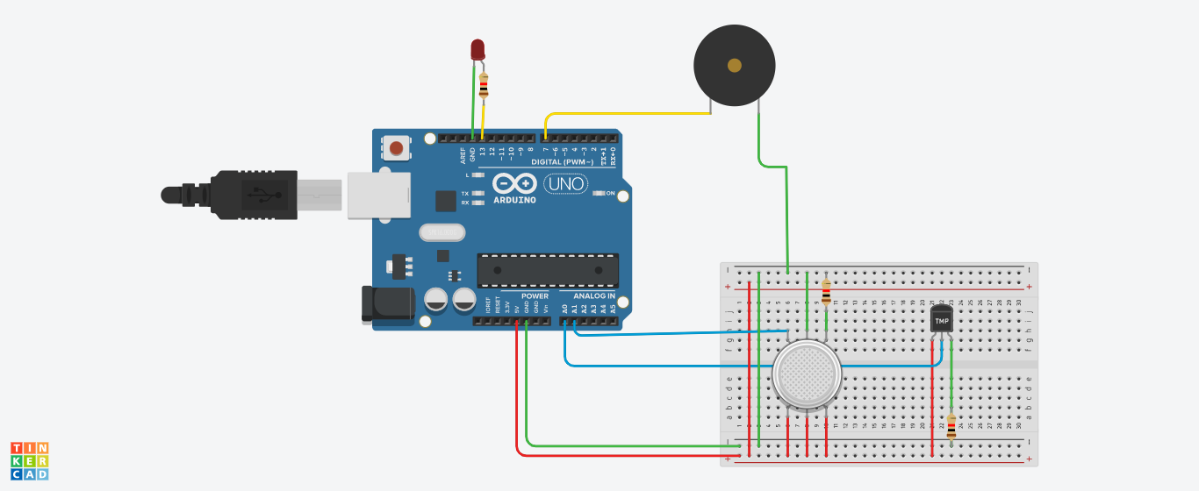

**Chapter 1**

**INTRODUCTION**

* 1. **Introduction**

➢ Fire Alarm System is designed to alert us to an emergency so that we can take action to protect ourselves, staff and the general public.

➢ Fire alarms are found in Offices, Factories, and public buildings, they are a part of our everyday routine but are often overlooked until there is an emergency at which point, they might just save our lives.

➢ Whatever the method of detection is, if the alarm is triggered, sounders will operate to warn people in the building that there may be a fire and to evacuate.

➢ The fire alarm system may also incorporate a remote signal system which could then alert the fire brigade via a central station.

➢ So what is a fire alarm system, or fire detection system? In this article, we will have a look at the structure and types of the “Fire Alarm Systems”.

**1.2 Objectives**

➢ A fire alarm system has a number of devices working together to detect and warn people through visual and audio appliances when [smoke](https://en.wikipedia.org/wiki/Smoke), [fire](https://en.wikipedia.org/wiki/Fire), [carbon monoxide](https://en.wikipedia.org/wiki/Carbon_monoxide) or other [emergencies](https://en.wikipedia.org/wiki/Emergency) are present.

➢ These alarms may be activated automatically from [smoke detectors](https://en.wikipedia.org/wiki/Smoke_detector), and [heat detectors](https://en.wikipedia.org/wiki/Heat_detector) or may also be activated via [manual fire alarm activation](https://en.wikipedia.org/wiki/Manual_fire_alarm_activation) devices such as manual call points or pull stations.

➢ Alarms can be either motorized bells or wall mountable sounders or horns. Fire alarm sounders can be set to certain frequencies and different tones including low, medium and high, depending on the country and manufacturer of the device.

➢ Most fire alarm systems in [Europe](https://en.wikipedia.org/wiki/Europe) sound like a siren with alternating frequencies. Fire alarm electronic devices are known as horns in the [United States](https://en.wikipedia.org/wiki/United_States) and [Canada](https://en.wikipedia.org/wiki/Canada), and can be either continuous or set to different codes. Fire alarm warning devices can also be set to different volume levels.

**1.3 Purpose, Scope, and Applicability**

**1.3.1 Purpose And Scope**

➢ Fire accidents can be controlled to a great extent in a places such as forests, colleges industries, homes, trains and some other public places

➢ Fire accidents leads to death of excess of people, by using this technique we can save those lifes easily

➢To detect the chain smokers(which are hazardous to health)

➢Preventing material damage

➢Preventing ecological damage4

|  |  |
| --- | --- |
| **Chapter 1. INTRODUCTION** | **2** |
|  |  |

**1.3.2 Applicability**

The guide will apply to all academic, residential, administrative, and storage buildings owned or leased by the College. This includes the installation of temporary systems that are incorporated into alterations and new construction during construction, demolition and renovation.

**1.3.3 Achievements**

We worked on fire detection system which is made using Arduino. A fire alarm system includes many components and features to help keep you protected. It saves lives by warning building occupants of emergencies so they can get out of danger. The typical components in a fire alarm system that provide protection and life-saving benefits.

Fire alarms are devices that are proven to save lives and are one of the most major investments your business and company can make. A fire alarm also called as a smoke detector or a smoke alarm basically emits a signal, whether it is a horn, siren or buzzer, as an alert or warning that a fire has started in the premises. The earlier a fire is detected by the fire alarm, the quicker it will be for the firefighters to respond. This means that you can easily avoid major damage to the property as we.

**Chapter 2**

**LITRERATURE SURVEY**

* A number of existing models were studied and their effectiveness was compared. Ahmed Imteaj et.al. Studied the problems faced by factory workers in times when fire breaks out. They proposed a system using Raspberry Pi 3 which is capable of detecting fire and providing information about area of fire. The Raspberry Pi controls multiple Arduino boards which are connected with several motors and cameras to capture the fire incident.In this, they discussed about the modern technology that can be us

* smoke sensors while developing the model. They present a preceding study of WSN is able to detect fire alarm. It is for setting up a wireless sensor network with three sensors. An application was developed for getting home information.

3

**Chapter 3**

**REQUIREMENTS AND ANALYSIS**

**3.1 Problem Statement**

To create a device which will help individuals to carry out tasks on their personal computers without actually giving commands through keyboard or mouse.

**3.2 Requirements Specification**

* Windows 7 or up
* Arduino IDE

5

|  |  |
| --- | --- |
| **Chapter 3. REQUIREMENTS AND ANALYSIS** | **6** |
|  |  |

* 1. **Software and Hardware Requirements**

**3.3.1 SOFTWARE -**

* **Arduino Software**

Arduino IDE will help us to burn/upload our code into Arduino’s microprocessor. Arduino code is very simple it will just print the string it receives through HC-05 module and print it on serial window of Arduino.



**3.3.1 HARDWARE -**

➢ Breadboard

➢ Wires

➢ ARDUINO R3

➢ Piezo Buzzer

➢ Resistor

➢ Gas Sensor

➢ Temperature Sensor

➢ Led

**3.5 Preliminary Product Description**

* We have used an Arduino UNO board. A fire alarm system has a number of devices working together to detect and warn people through visual and audio appliances when [smoke](https://en.wikipedia.org/wiki/Smoke), [fire](https://en.wikipedia.org/wiki/Fire), [carbon monoxide](https://en.wikipedia.org/wiki/Carbon_monoxide) or other [emergencies](https://en.wikipedia.org/wiki/Emergency) are present.

**Chapter 4**

**SYSTEM DESIGN**

Describes desired features and operations in detail, including screen layouts, business rules, process diagrams, pseudo code and other documentation.

**4.1 Basic Modules**

Logic diagram:

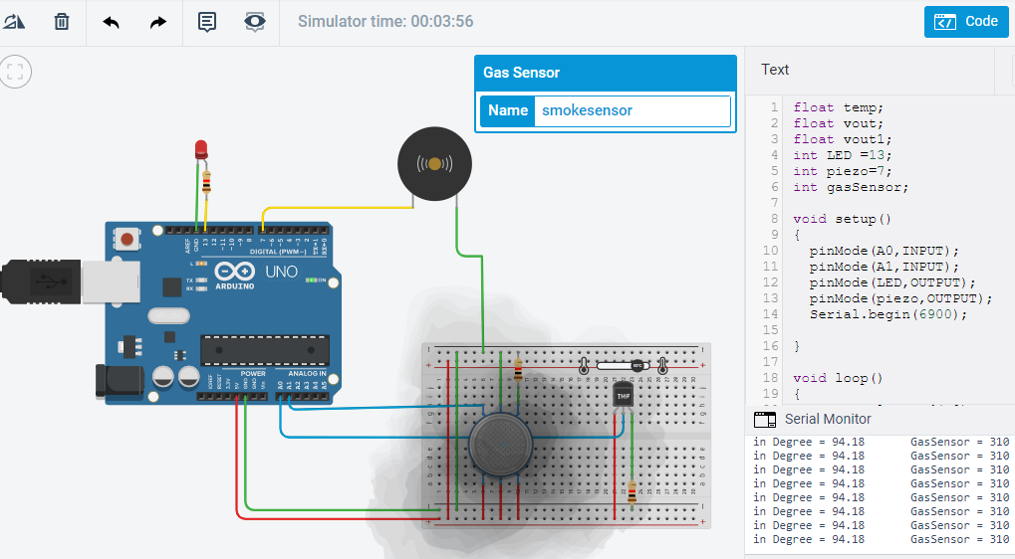

**4.1.1 Circuit Diagrams**



|  |  |
| --- | --- |
| **Chapter 4. SYSTEM DESIGN** | **8** |
|  |  |

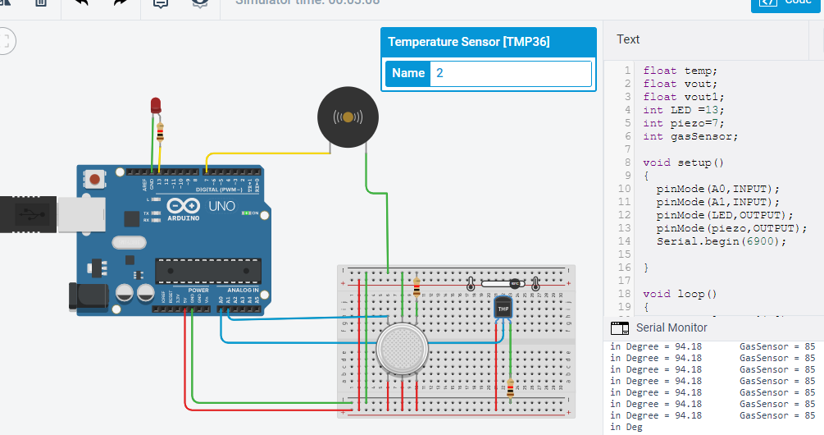

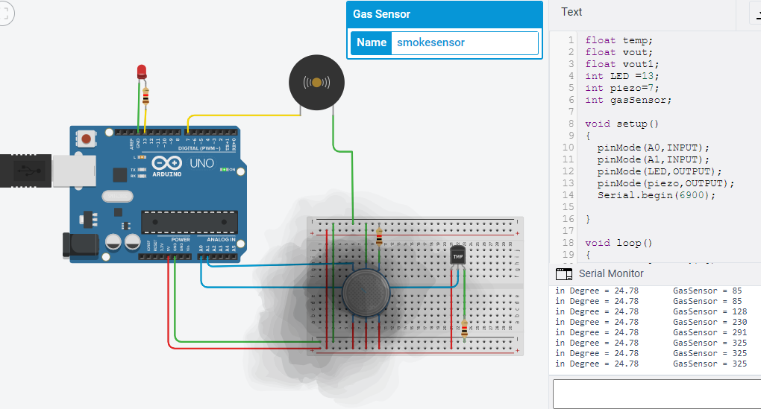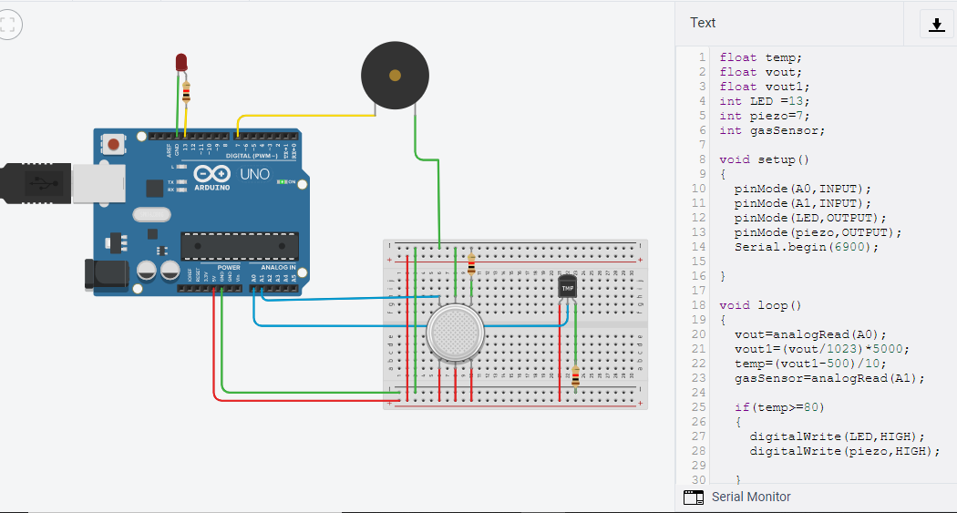

**Chapter5**

**IMPLEMENTATIONS**

**5.1 Hardware Implementation**

In a Fire alarm system two sensors are used one is gas sensor and another one is the flame sensor. whenever the temperature high is detected by the flame sensor then LED with Buzzer is high means led its glow and the buzzer is produces an alert sound. as well as the smoke or gas is produce and detect by gas sensor then LED with Buzzer is high means led its glow and the buzzer is produces an alert sound. it's necessary to control and avoid an emergency situation..

**5.2 software Implementation**

Software design is divided into two parts. First we write the Arduino program

in Arduino software. Then we compile it to the Arduino hardware. This Arduino command is control the Arduino hardware and other circuit and display connection.

**Installing Arduino, Arduino runs on Windows**.

Go to the Arduino software web site at <http://arduino.cc/en/Main/Software> and download the version of the software compatible with our system. We use Arduino

1.0.5 version.

**Arduino Language**

The Arduino language is implemented in C/C++ and based in Wiring. When

we write an Arduino sketch, we are implicitly making use of the Wiring library, which

is included with the Arduino IDE. This allows us to make run able programs by using

only two functions: setup () and loop (). As mentioned, the Wiring language is

inspired by Processing, and the Arduino language structure is inherited from the

Processing language, where the equivalent functions are called setup (). We 51 need to

include both functions in every Arduino program, even if we don’t need one of them.

Let’s analyze the structure of a simple Arduino sketch using again the Blink example.

**Chapter 6**

**CONCLUSIONS**

**6.1 Conclusion**

A fire alarm is a device that detects the presence of fire and atmospheric changes relating to smoke. The fire alarm operates to alert people to evaculate a location in which a fire or smoke accumulation is present. When functioning properly, a fire alarm will sound to notify people of an immediate fire emergency. This distinct sound exists to allow the notification to be heard The fire alarm constructed by this project work is reliable at low cost.

**6.2 Limitations of the System**

Any alarm system is subject to compromise or failure to warn for a variety of reasons. For example: Particles of combustion or “**smoke**” from a developing fire may not reach the sensing chambers of the **smoke detector** because: - Barriers such as closed or partially closed doors, walls, or chimneys may inhibit flow.

**6.3 Future Scope of the Project**

Fire accidents can be controlled to a great extent in a places such as forests, colleges industries, homes, trains and some other public places Fire accidents leads to death of excess of people, by using this technique we can save those lifes easily To detect the chain smokers(which are hazardous to health)Preventing material damage Preventing ecological damage

**Reference**

* https://www.arduino.cc/en/Main/Software
* https:// TINKERCAD.COM